**Name: PARAS RATHI**

**Roll No: BIT-24S-007**

**LAB 4:**

**TASK 01**

Write a python program to take 2 numbers as input and perform all arithmetic operations on them.

**Program:**

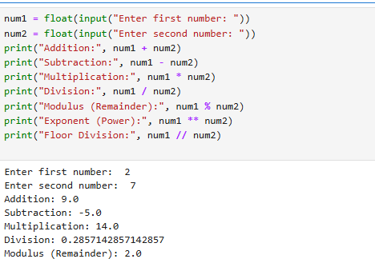

**TASK 02**

Create a function that takes two numbers and return their sum, difference, product, and quotient.

**Program:**

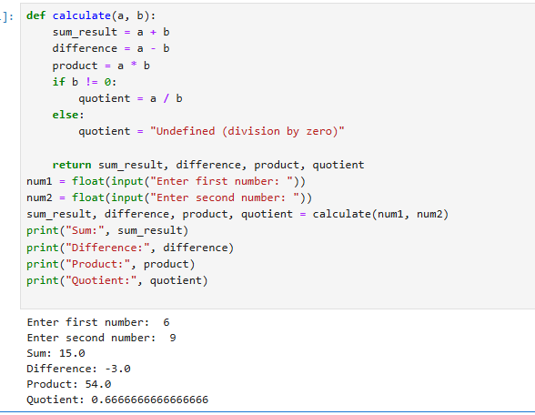

**TASK 03**

Write a python script to find the remainder when one number is divided by another.

**Program:**

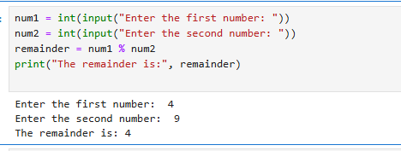

**TASK 04**

Write a program to calculate the area of a circle using the formula: area=pi*r^2.

**Program:**

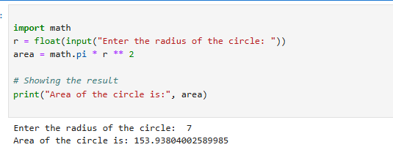

**Task 05:**

Implement a program that takes a number as input and returns its square and cube using exponentiation.

**Program:**

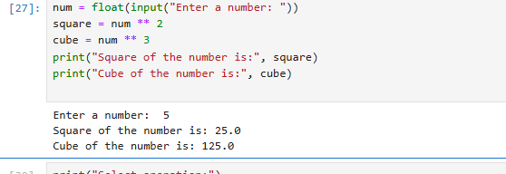

**TASK 06:**

Create a simple calculator in python that allows the user to choose an operation(addition, subtraction, etc.)and inputs two numbers.

**Program:**

